[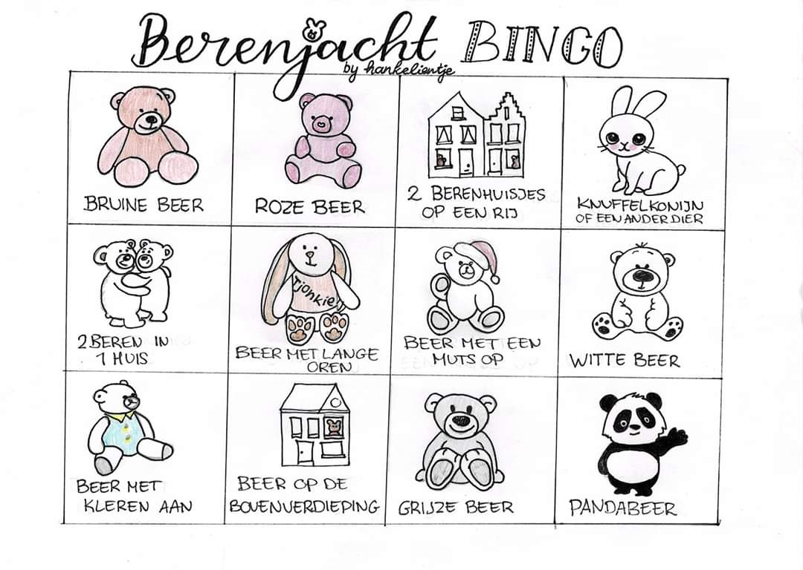](https://www.google.nl/url?sa=i&url=https%3A%2F%2Fberenjachtkaart.nl%2Fdocumenten&psig=AOvVaw1ynlucgjZYOL9ZA1d982MZ&ust=1586160121804000&source=images&cd=vfe&ved=0CAIQjRxqFwoTCIjU0IXp0OgCFQAAAAAdAAAAABAt)